JANTA VIDYA MANDIR GANPATRAI RASIWASIA COLLEGE, CHARKHI DADRI
Faculty Profile

Department of Economics

Name of Faculty |  | Dr. Garima Sheoran |  |  | 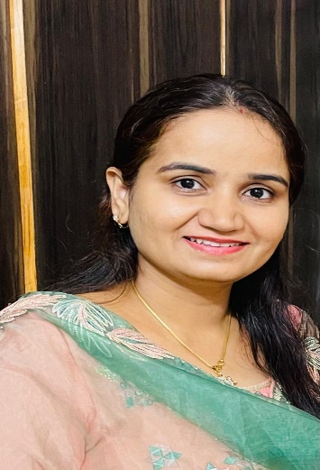
Department |  | Economics
Designation |  | Assistant Professor
Experience |  | 11 yrs 6 months
Contact No |  | 7206306362
Email Id |  | garimasheoran@gmail.com
Date of Joining |  | 2nd July 2013
Educational Qualification:
 | Name of Program |  | Year of  Passing | University
PG | M.A Economics |  | 2012 | Maharshi Dayanand University, Rohtak
Ph.D. | Economics |  | 2024 | Maharshi Dayanand University, Rohtak
Net | UGC-NET-JRF |  | 2012
Other
Research Supervision/Guidance
Research Publications |  | 4
Books Published |  | NA
Book Chapters |  | NA
Papers Presented in Conferences/ Seminar |  | International: National: 8
Participated in Conferences/ Seminar |  | International: National:
No. of Workshops/FDP/Training Programme Attended |  | 4
Major/Minor Research Projects |  | NA
Invited Lectures |  | NA
Awards/Honours |  | NA
Membership of Any  Professional/ Statutory Body |  | NA
Any Other Achievement |  | NA

